Our team in the physical world:

{photo of team}

{list of team members from photo left to right – one sentence about each]

- person: line about them

Our mascot:

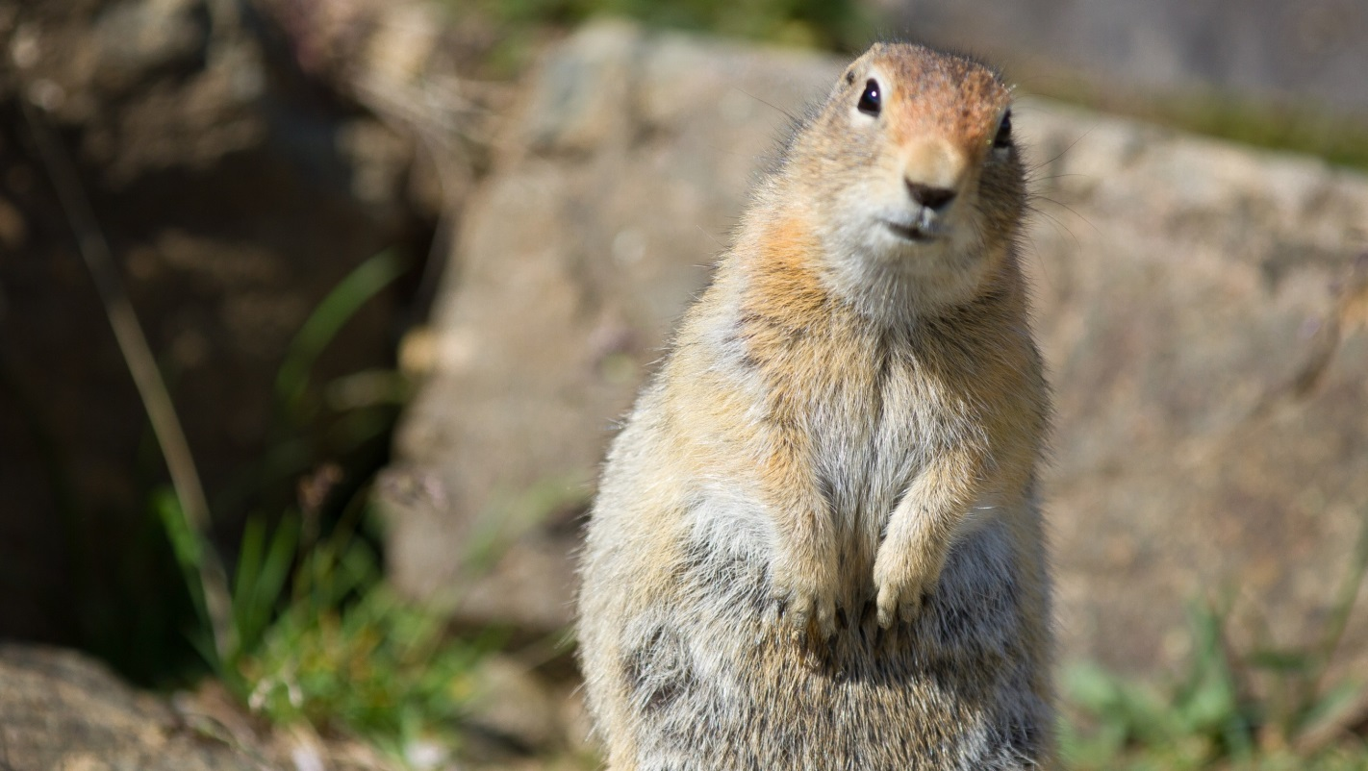

Slack to communicate

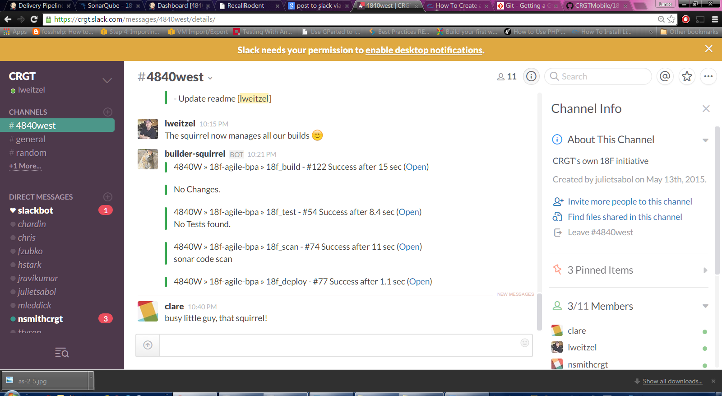

We use Asana to track our work:  
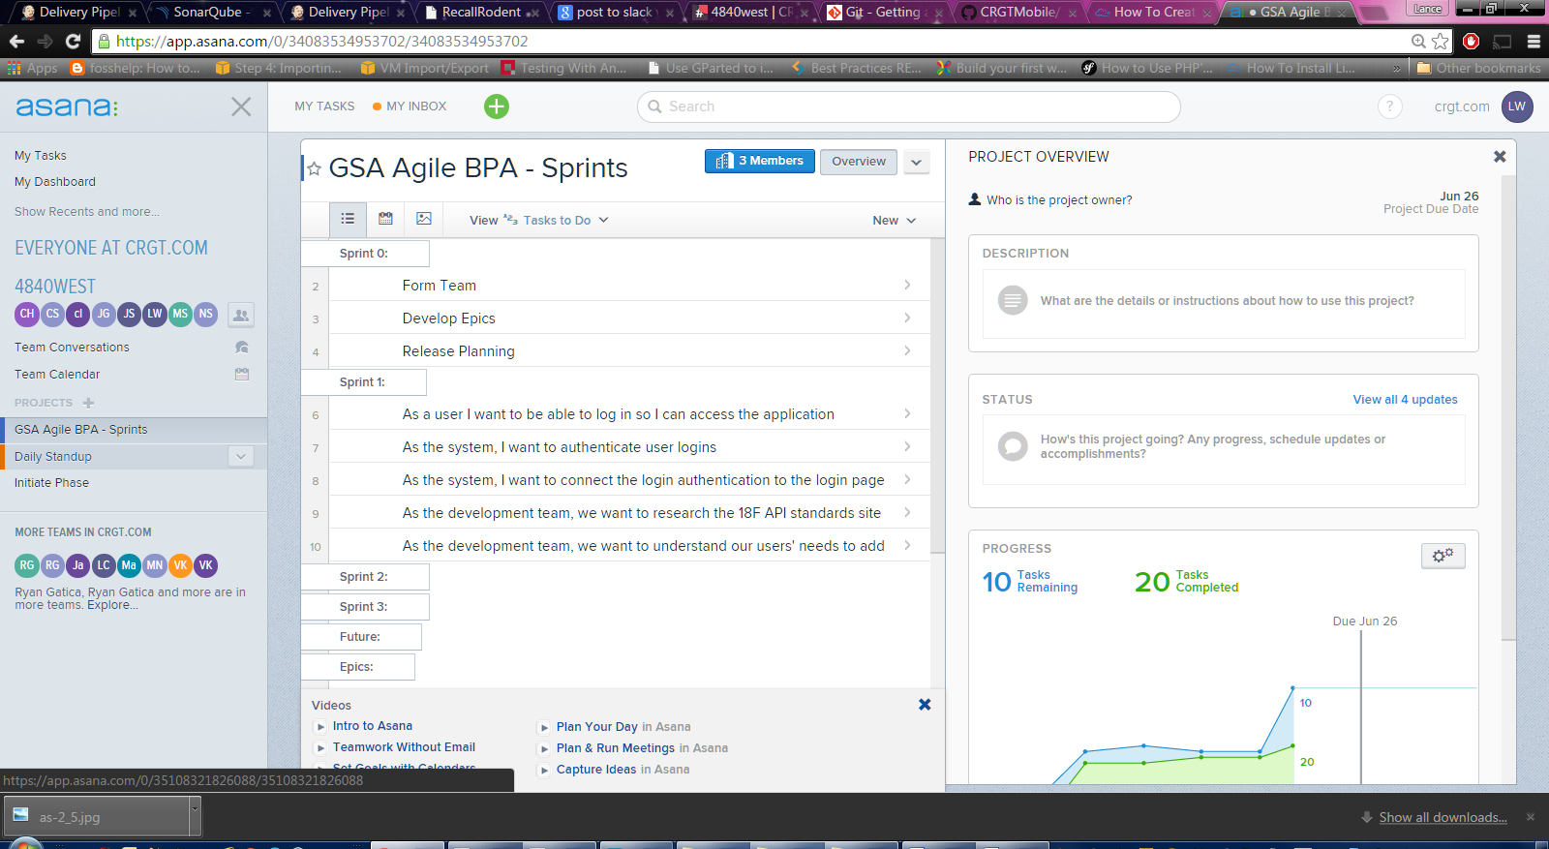

Our Jenkins main folder for continuous integration

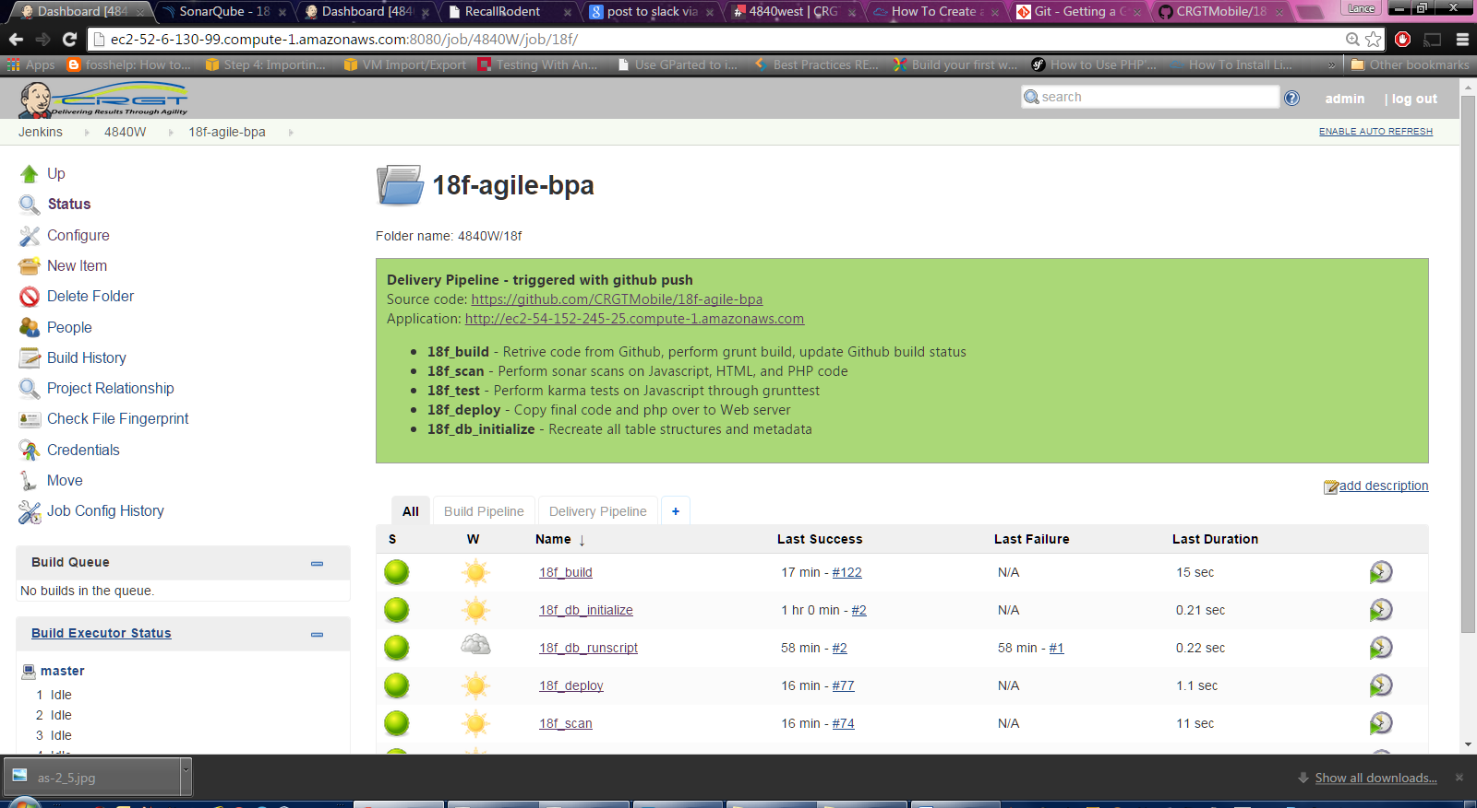

The delivery pipeline

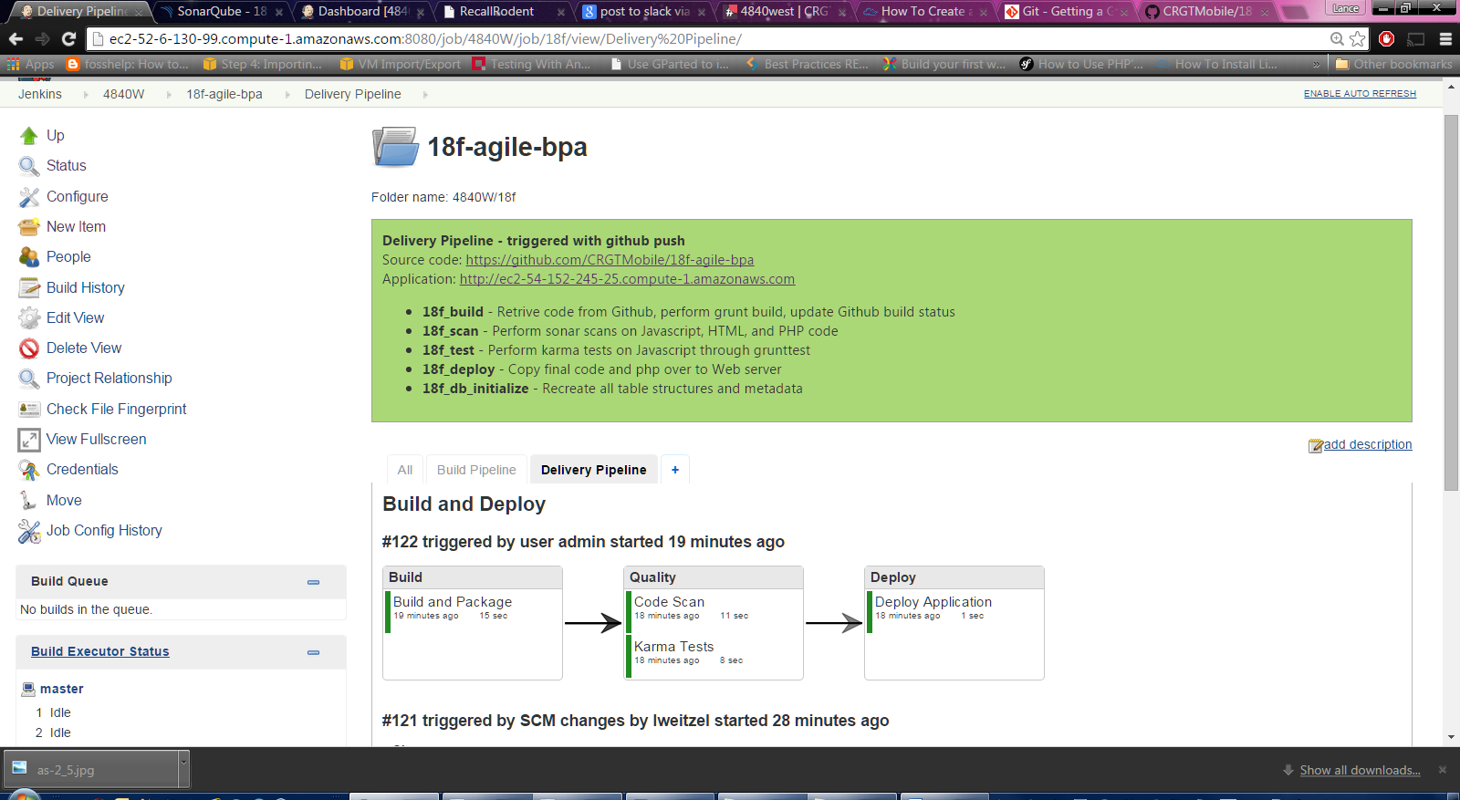

Our sonar quality scans

